

**Recipes For Life**

**User Guide**

**Kari McMahon**

**AC40001 Honours Project**

**BSc (Hons) Applied Computing**

**University of Dundee 2015**

**Supervisor: Dr Keith Edwards**

Table of Contents

Application Front Page 3

Users Cookbook Screen 4

Users Recipe Screen 6

Viewing A Recipe Screen 7

Editing A Recipe Screen 8

Recipe Search Screens 9

Navigation Bar 10

Recipe Explore Screens 11

# Application Front Page

The first screen which that is displayed to the user handles the signing in and signing up of the user. The user can either log in if they already have an account or create an account if they don’t. The user signs in by entering their email or password and pressing log in. The user creates an account by clicking the link called “create an account” which displays a dialog with a form for the user to fill out and once these details are filled out and checked the user is then logged in to the application. The user must fill out a valid email which is not already in use and a password which contains a capital letter, a digit and a special character before the account will be created.

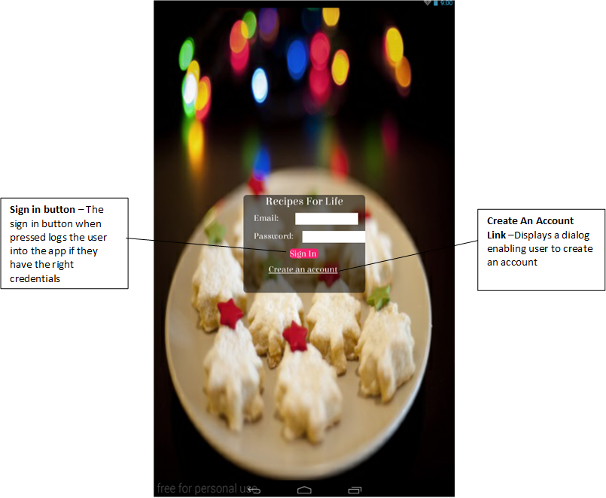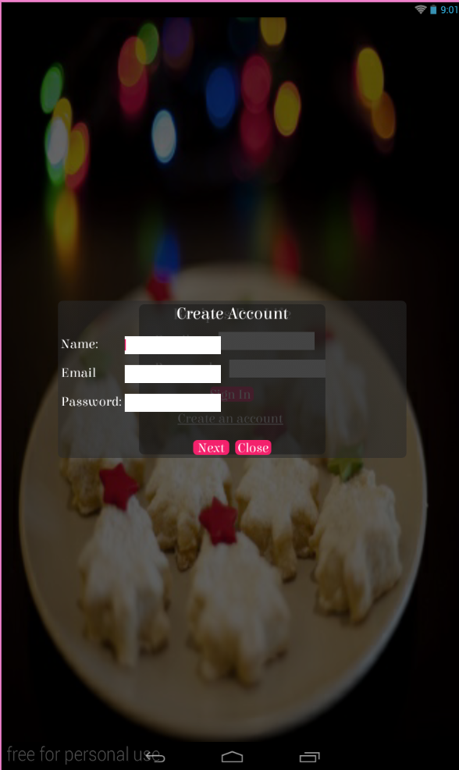

# Users Cookbook Screen

When the user is logged in to the application the first screen they will be shown is their cookbook shelf. If it is their first time in the application it will be an empty shelf. The shelf will contain the cookbooks they own and the cookbooks they are a part of. On this screen at the top of the app in the action bar there is a plus icon when this is clicked it enables the user to add a new cookbook to the shelf.

**Cookbook Owner View**

If the user owns the cookbook they will see 3 icons next to the cookbook - a pen and paper icon, a user icon and a dustbin icon. If the user clicks the pen and paper icon this enables the user to edit the cookbook. If the user clicks the user icon this enables the owner to view the contributors in the cookbook and add a new contributor or delete a contributor. If the user clicks the dustbin then this enables the user to delete a cookbook.

**Cookbook Contributor View**

If the user is a contributor to a cookbook they will only see the user icon next to the cookbook image. If the user clicks this icon they can see the contributors who are part of this cookbook.

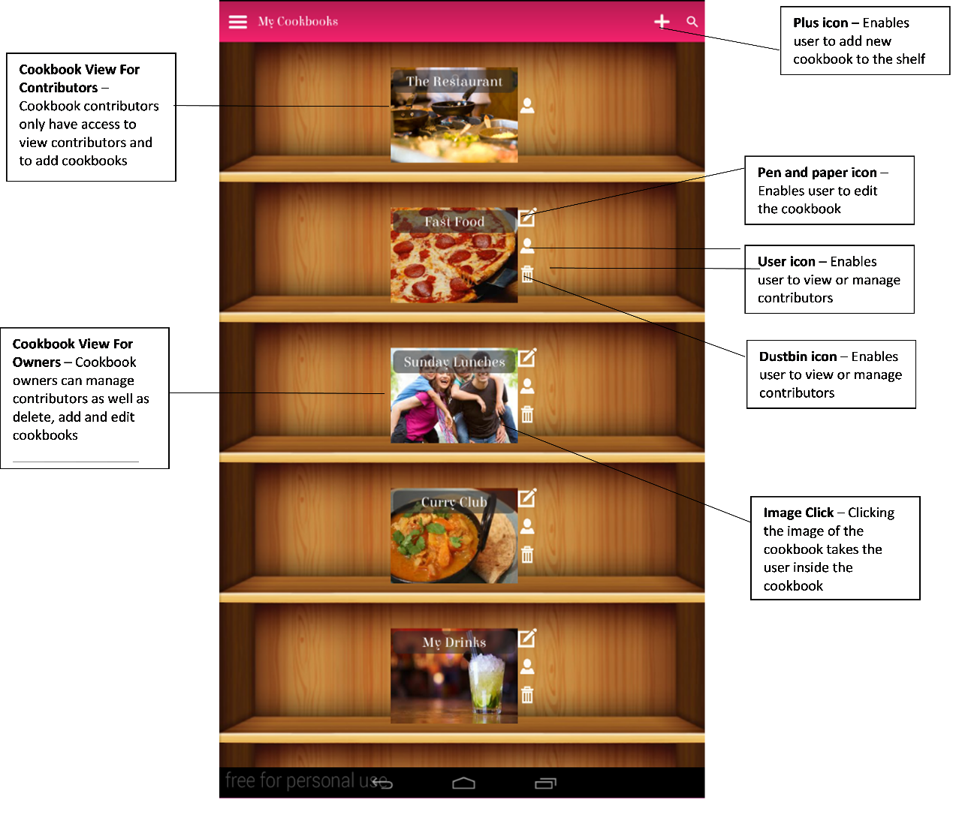

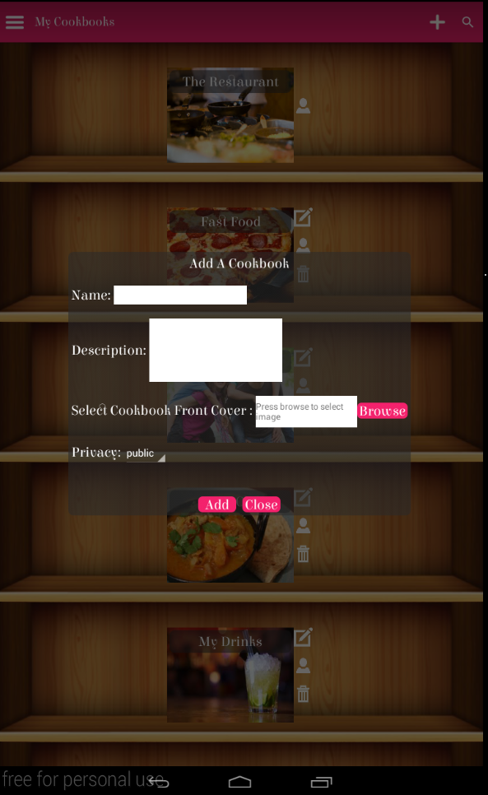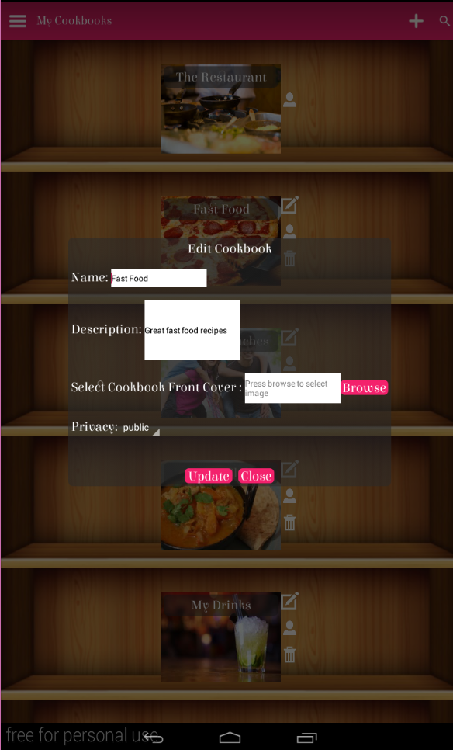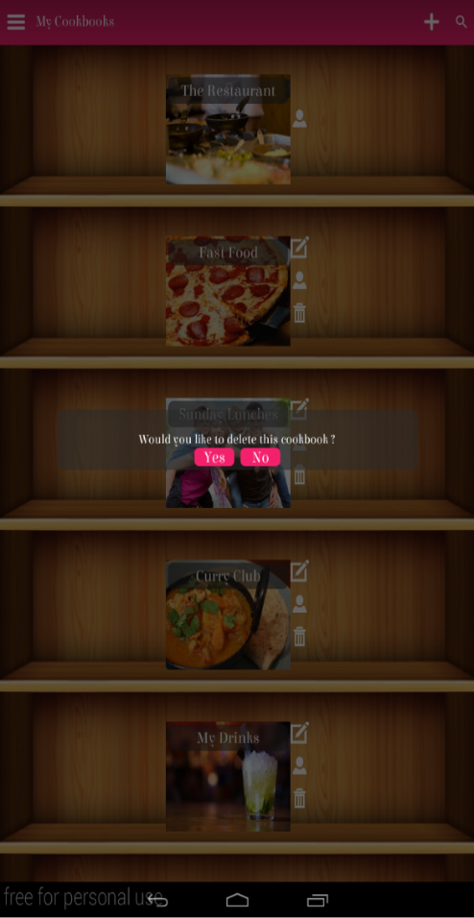

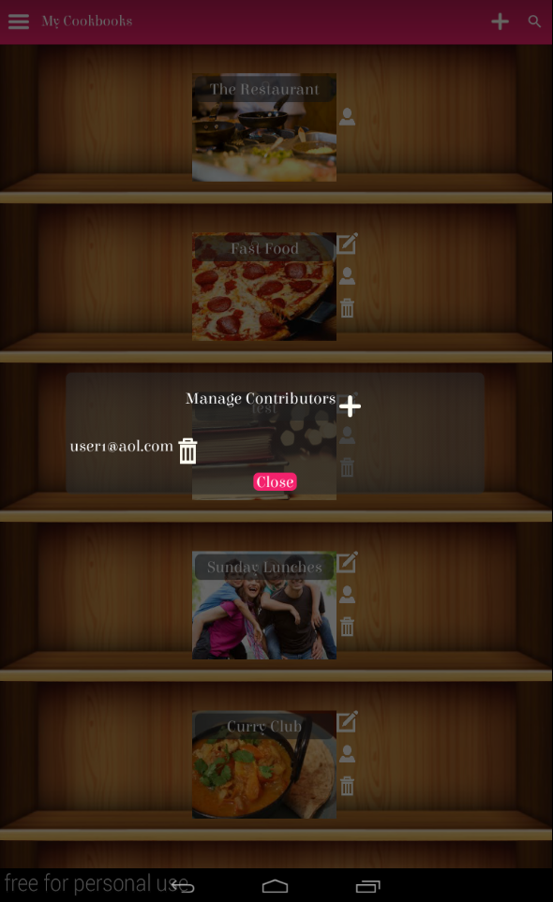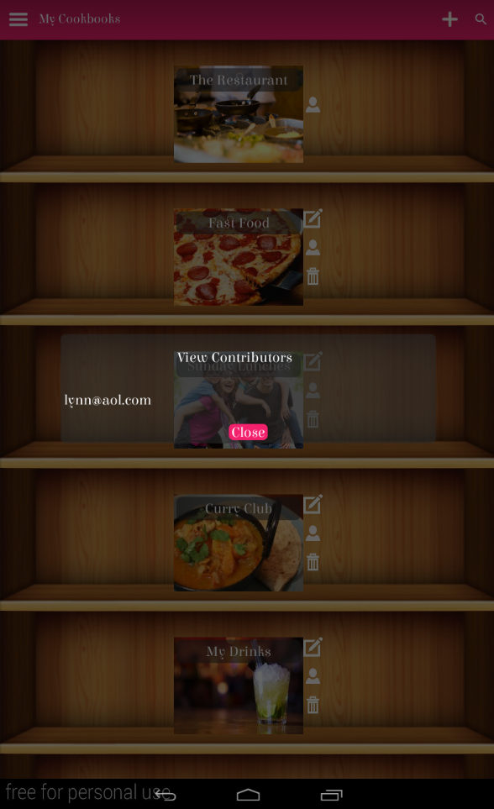

# 

# Users Recipe Screen

If the user clicks the cookbook image it will take them to the recipe shelf. This is a shelf of the recipes contained within the cookbook. The user will see 2 icons next to the recipe image which is the pen and paper icon and the dustbin icon. Clicking the pen and paper icon will take you to a page where you can edit the recipe and clicking the dustbin icon will enable the user to delete the recipe. At the top of the application in the action bar there is a plus icon this enables the user to add a new recipe into the cookbook and there is a copy icon this enables the user to copy any recipe from the shelf into any cookbook they own under a new name.

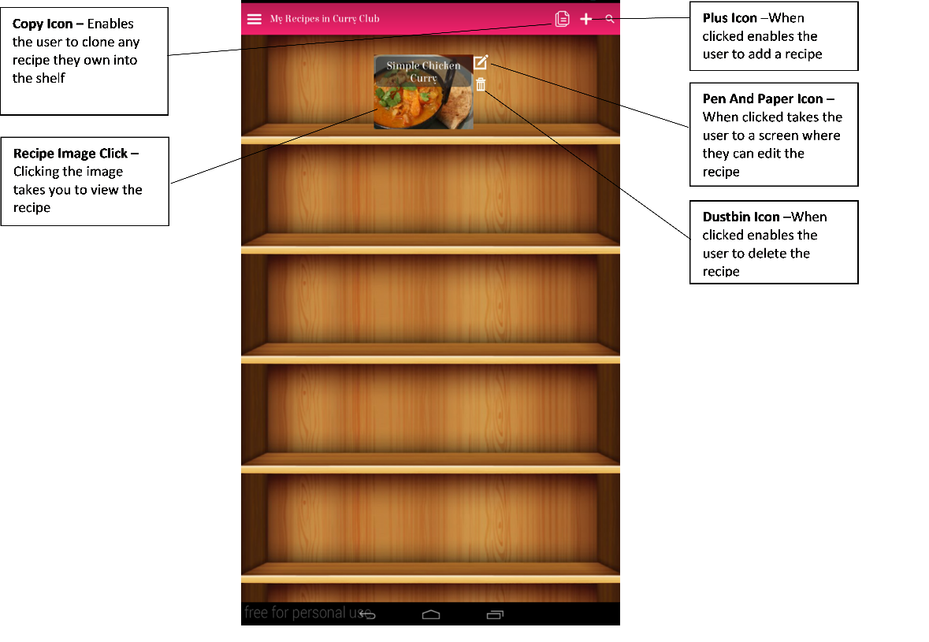

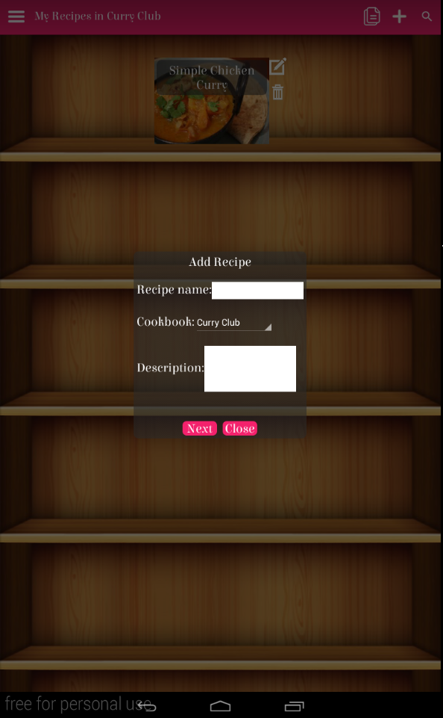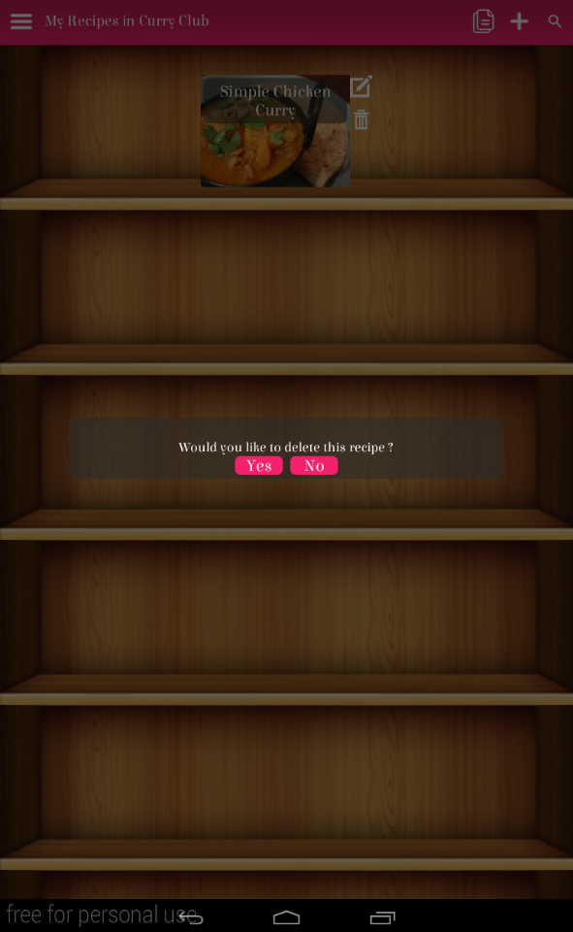 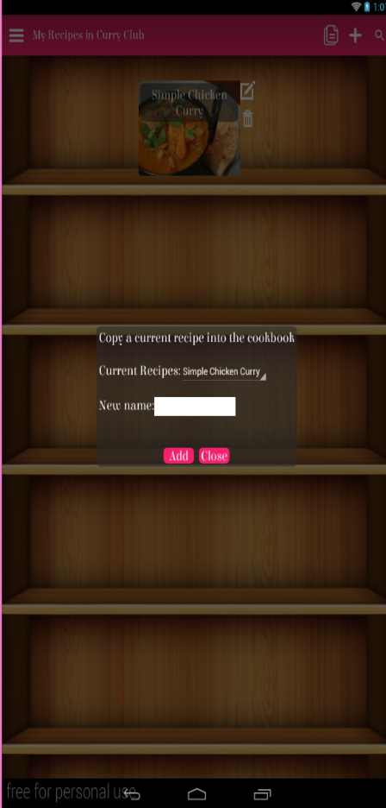

# Viewing A Recipe Screen

If the user clicks on the recipe image it will take them to the recipe view page which shows the recipe. It outlines the ingredients and steps in the recipe as well as its dietary requirements, prep/cooking times etc. At the bottom of the recipe any user can add comments, review or alterations which help to create collaboration. On the action bar at the top several icons are there to help improve the recipe view. There are two icons to increase and decrease the font size to make the recipe easier to read. There is an icon to make the recipe full screen so the recipe will take up the full screen. There is an icon which when clicked will stop the screen from sleeping so the user doesn’t have to click the screen to do this when cooking. There is a copy icon so the user can copy the recipe into a cookbook they own.

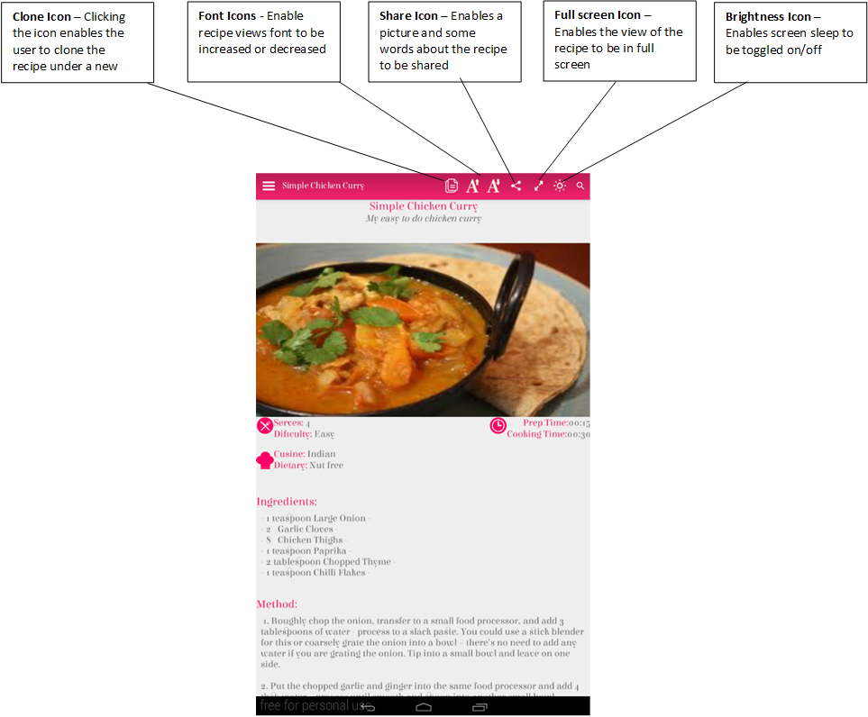

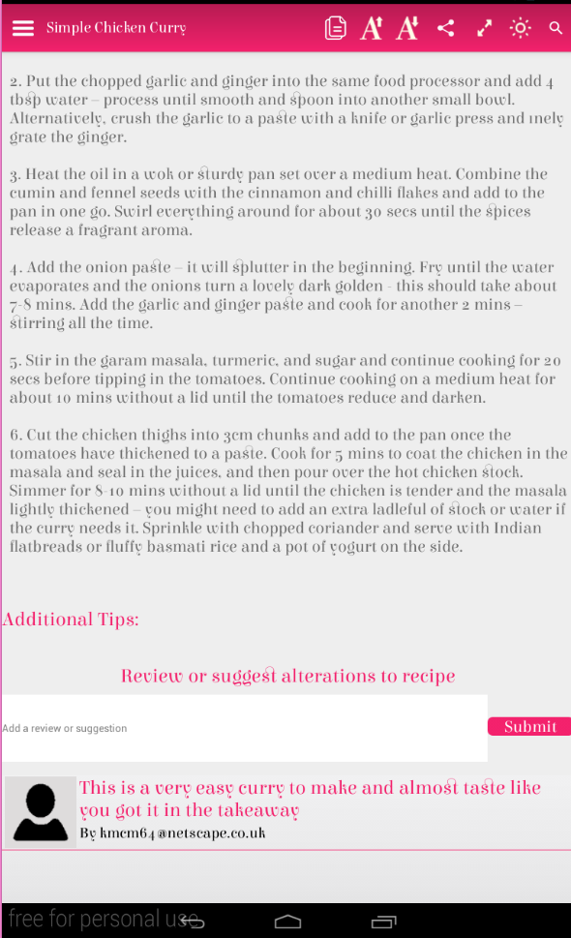

# Editing A Recipe Screen

In the recipe shelf if the user clicks the pen and paper icon it will take them to a page where they can edit a recipe. It looks similar to the recipe view but has pen and paper icons at different sections of the recipe which when they are clicked enables the user to edit that part of the recipe. At the bottom of the page there is a save button where the user can save changes to the recipe and when the user leaves the page they are asked if they want to save.

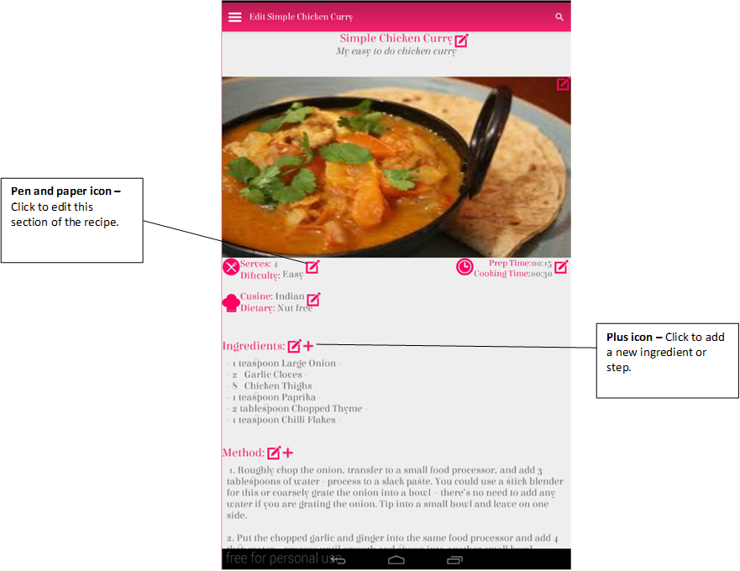

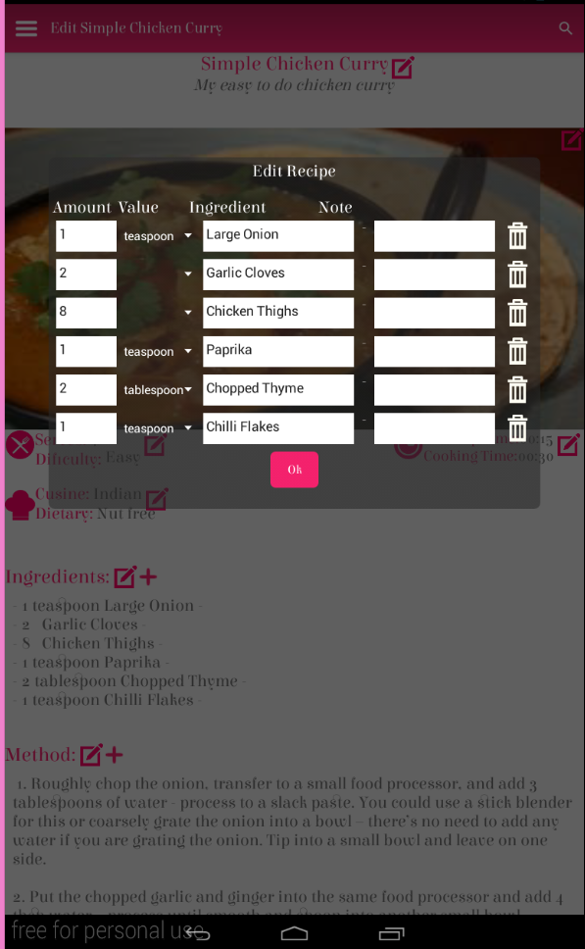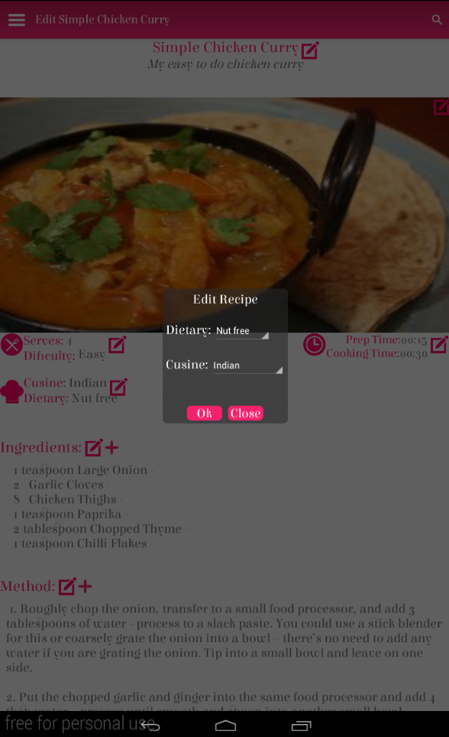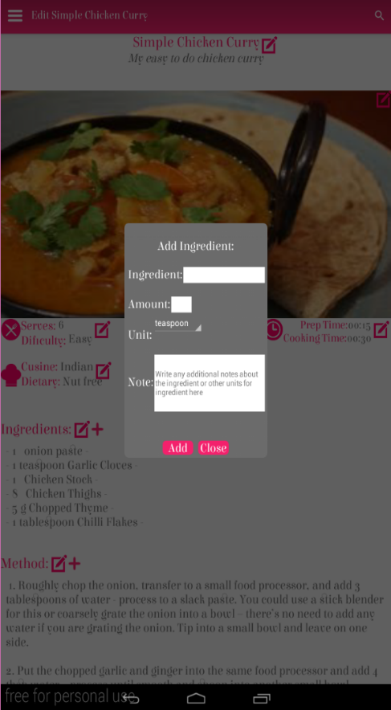

# Recipe Search Screens

In every screen in the app a search icon can be seen in the right hand corner of the action bar. When clicked this enables the user to input a query. The app searches for recipes, cookbooks or users that contain this query and then output the results in a results page.

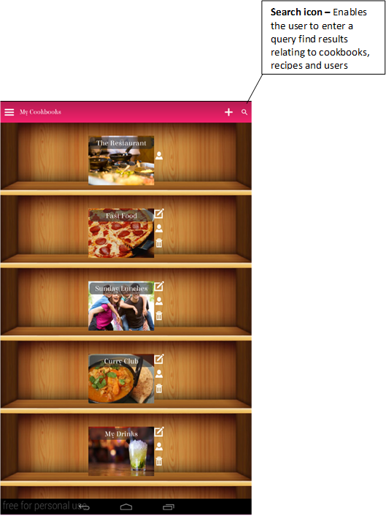

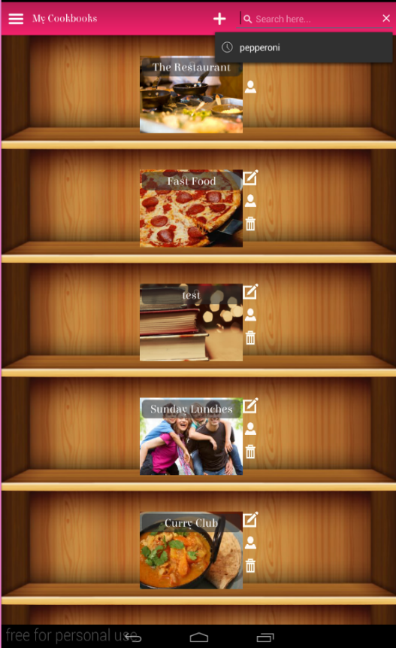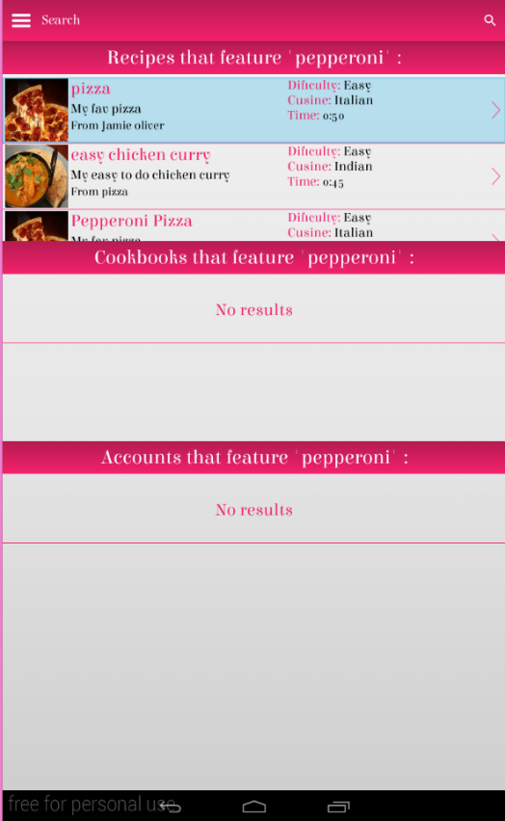

# Navigation Bar

In every screen in the app on the left hand side in the action bar is a menu icon which when clicked shows a navigation bar. This bar enables the user to return to the homepage, explore for new recipes or log out the application.

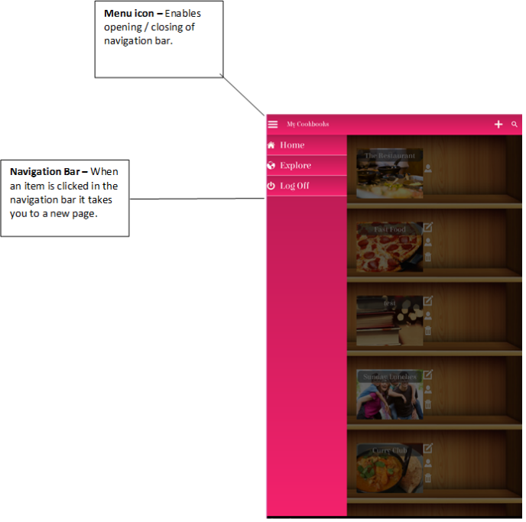

# Recipe Explore Screens

In the navigation bar there is an option called explore. When clicked this displays the option to find recipes by difficulty, cuisine or dietary requirements or to find cookbooks. When an option is clicked it will display a results page showing a selection of recipes or cookbooks that fit the requirements.

